March 2019
THE KEYSTONE HIKER
Preserving Pennsylvania’s Footpaths since 1956

Contact us: 46 E Main St, Mechanicsburg, PA 17055 / 717-766-9690 / ktaadmin@kta-hike.org

Member’s Corner

Member Spotlight
Member Christine Inman informed us that she has plans to throughhike the Appalachian Trail, starting March 17th, through September. Good luck Christine!

Mid State Trail
Mid State Trail Association, the all-volunteer non-profit group that cares for Pennsylvania’s longest and wildest footpath ( 2019 Pennsylvania Trail of the Year! ) announces the Hike 50! Celebration in honor of Mid State Trail’s 50 ^{th} anniversary.
MST began as a project of Penn State Outing Club in 1969, and grew to cross all of PA in association with PA Department of Conservation and Natural Resources (five state forests, eight state parks, and general support directly and through Keystone Trails Association), Pennsylvania Game Commission (six numbered game lands), U.S. Army Corps of Engineers Tioga-Hammond and Cowanesque Lakes, and about two dozen private landowners.
In addition to the ongoing MST End to End and MegaMeter recognition ( details here), during this 50th anniversary year 2019 (through New Year’s Day 1/1/2020), we have a special offer to those who sample the MST system. Hike 50 kilometers (km) along Mid State Trail – 10 km each (individually or cumulatively) in at least four different parts of Mid State Trail:

- Everett Region – from MD Route 144 north to US Route 22, guidebook sections 0 through 6;
- State College Region – from US 22 to PA Route 192 at Raymond B. Winter State Park, guidebook sections 7 through 11;
- Woolrich Region – from PA 192 north to PA Route 414 at Blackwell, guidebook sections 12 through 16;
- Tioga Region – from PA 414 north to the New York State border, guidebook sections 17 through 20.

The final 10 km to make a total of 50 km in 2019, can be (individually or cumulatively) along more of Mid State Trail beyond the minimum in each region – and/or along a list of trails from Virginia to Ontario, Canada, that connect to MST.
Hikers do not need to register with MSTA until the Hike 50! is completed. However, hikers on this quest are encouraged to use the social media hashtag #Hike50MST
See form posted in the “Mid State Trail” Facebook group and on the MST web site www.hike-mst.org
MST offers new options to hikers seeking map and guide information to hike either 50 km or End to End:

- The official paper guidebook and waterproof maps are available again from the MST web siteafter many months in 2017 and 2018 of being out of stock. You may need to keep scrolling down to see the order links from some smartphones and tablets. Purchasing maps and guide information through the MSTA website offers the most current information, and the most financial support to keep PA’s longest and wildest footpath cleared and marked. The map and guide set can also be ordered from KTA.
- On those smartphones and tablets (iOS and Android), MSTA has partnered with Atlas Guides Guthook app offering MST hiking information as an in-app purchase. A portion of the purchase price supports MSTA.
- Purple Lizard Maps, between their Raystown, Rothrock, Bald Eagle, and Pine Creek maps, shows sections 5 through 17 of MST. While this is not the entire footpath, it is enough to show areas qualifying for the #Hike50MST
Any questions, e-mail end2end@hike-mst.org

Donations
Did you know that KTA will accept non-monetary donations? We'll gladly take your old boat, car, etc! We're specifically looking for a 12 or 15 passenger van to use on our slack packs and to shuttle hikers on a variety of our programs.
If you have something you'd like to donate, please contact Joe Neville at ktahike@kta-hike.org

Volunteer/Maintainer’s Junction

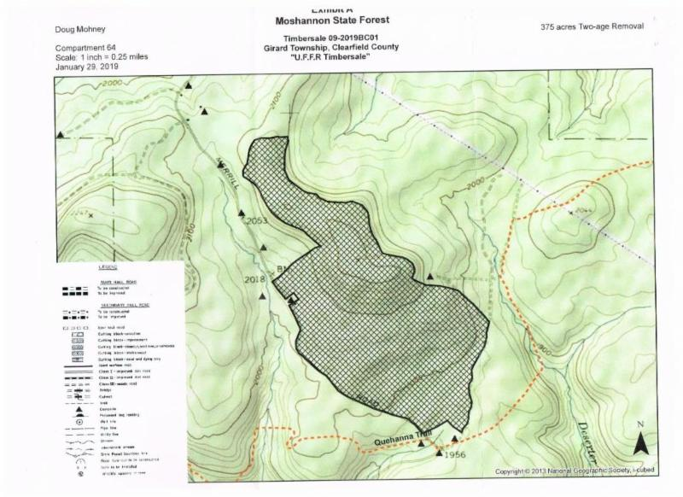
Upcoming Trail Alert!
There is an upcoming timber sale in the Moshannon State Forest. The cutting is anticipated to take place in June 2019, but should not have an effect on trails. For more info, read the letter here.

Volunteer Opportunity
The Appalachian Trail Conservancy will be hosting a Greenways and Trails Summit and is in need of volunteers!
This 3-day statewide summit provides exceptional training and networking opportunities for those engaged in all aspects of trail and greenway work, including planning and economic professionals; trail and conservation staff, board and volunteers; park professionals; local, county, and state government officials; consultants and builders; and trail enthusiasts. The summit, which will be held September 22-24, 2019 at the Shippensburg Conference Center, will offer dozens of educational sessions, 5-7 mobile seminars, keynote presentations, discussion panels, and various networking opportunities.
This summit is presented by the Pennsylvania Land Trust Association with generous support through the Pennsylvania Department of Conservation & Natural Resources. Click here for more .

VOLUNTEER OPPORTUNITIES
A conference of this size and complexity simply would not be possible without the help of volunteers on the ground. Volunteers are needed to assist in all areas of the conference, including:

Registration desk: Welcoming attendees and assisting them with directions, handing out badges and materials, processing walk-in registrations and answering general queries as needed.

Room hosts: Welcoming speakers, assisting with distribution of materials, and providing additional support as needed.

A/V & Speaker Support: Assisting speakers with material transport, venue directions, and A/V support as needed.

Exhibitor Support: Directing exhibitors to their assigned tables and assisting with transport of materials, as well as assisting with set-up as needed.
We are also currently soliciting volunteers for the following special assignments:

Social Media Coordinator(s)
Social media is a great way to create interest and excitement around the summit. We’re looking for 1-2 volunteers who are knowledgeable of various social media platforms (e.g., Facebook, Twitter) to develop posts and imagery that help to promote the summit, engage potential attendees, and build an audience for future summits.

Summit Photographers
A chance for professional or accomplished amateur photographers to do what they love, and help us capture those special moments at the summit. Images will be used in both print and web formats for publicizing the summit. Attribution will be given to the photographer.

Leisure Activity Leaders
From facilitating breakfast discussion topics and organizing networking receptions, to leading yoga classes and/or organizing runs, trail walks & rides outside of instruction time, volunteers are needed to organize and administer leisure time and networking meet-up activities for conference attendees.

TO APPLY
Interested volunteers should email the volunteer coordinator at: cgrayshaw@conserveland.org .

In your email, please include: name, best e-mail and contact phone number, area(s) of volunteer interest and a general idea of your availability between Sunday, September 22 & Tuesday, September 24. A member of the volunteer sub-committee will be in contact to discuss scheduling.

Thank you for your interest in the Greenways & Trails Summit, 2019!

Sign Up for 2019 Events NOW
Click on the photos below to get more information

Spring Hiking Weekend  Quehanna Elk Quest | Black Forest Slackpack  Laurel Highlands Slackpack | Trek the Tiadaghton  Adventure in the Allegheny

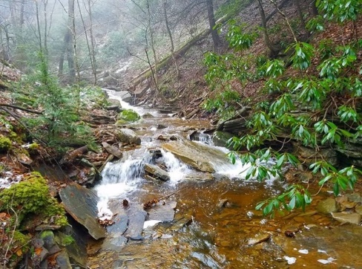
Jeff's Jaunts
Exploring Sullivan Mountain and Buck Run-Loyalsock State Forest
Check out Jeff Mitchell's gorgeous photos from his recent hike in the Loyalsock State Forest. " The grade was a very nice hike as it traversed the southern edge of the plateau, passing small fern meadows. Through the trees I could see over Pleasant Stream’s valley. I loved the isolation of this route. I soon reached a small, unnamed stream. My bushwhack began."

Community Calendar

Blue Mountain Eagles Climbing Club
SATURDAY, MARCH 16, 2019 – CELTIC BREAKFAST FUNDRAISER FOR RENTSCHLER ARBORETUM At the Bernville Grange, Shartlesville Road, Bernville from 9am-1pm. Breakfast 9-1. Music by the Root Blossoms 9:30-11:30. Best Legs in a Kilt Contest at 10:30. Vendors, artisan crafts and fun. Arboretum tours. Call for reservations, $15.00, by March 12 at 610-775-3004. Seating is limited.
Rentschler Arboretum is a 34 acre property of Blue Mountain Eagle Climbing Club, open to the public, established by our founder Dr. Harry Rentschler. It is used for outdoor recreation and educational programs for community, schools and scouts. This year's proceeds will help fund upgrades to our privy. Click here for more upcoming events with the Blue Mountain Eagles Climbing Club, click here!

Batona Hiking Club
SUN. 03, TYLER STATE PARK, 18940. 5-6 miles. Depart Fox Chase Train Station at 10:30 AM. (15 miles to trailhead). The trailhead meeting location is the Fisherman’s Parking Lot across from the Spring Garden Mill Theater on Route 332 at approximately 11:15 AM. This park features the Neshaminy Creek and a covered bridge. There are a number of old farm houses, which we will stop to look at. This is not a fast paced hike. Cost: $1.00. Leader: Bob Miller, 215-885-0969. (C) 267-428-9938 on day of hike only.SUN. 03, TINICUM PARK TO HOMESTEAD STORE VIA DELAWARE CANAL, 18972. 10 miles. Meet at Bucks County - Tinicum Park, 963 River Road (Route 32) Upper Black Eddy, PA at 10:00 AM. Easy scenic route. Eat at the home stead store, built in 1832. Possible talk by UBE resident whose grandparents were Lock-Keepers on the canal. Cost: $1.00. Leader: Susan French, 610-847-5709. **If the weather forecast is unfavorable, check the Batona Meet-up site for possible cancellation.
SUN. 10, PULPIT AND PINNACLE, 19526. 13+ miles. Day hikers depart G & R at 7:45 AM (70 miles to trailhead). Come and enjoy the views from Pulpit and Pinnacle. Hike has two STRENUOUS climbs. Most of the time will be on the Appalachian Trail with a bypass to Hamburg Reservoir. Hiking boots and poles recommended. Cost: $1.00 for day hike. Carpool includes $0.10 per mile round trip plus tolls. Leader: Mike Hughes, 267-784-5756, deecrismel@comcast.net
SUN. 10, OKEHOCKING PRESERVE, 19073. 5-6 miles. For those coming by public transportation, I will meet the SEPTA Route 104 Bus at West Chester Pike and Providence Road at 9:40 AM. For those driving to the trailhead, we will meet in the parking lot located at 996 Delchester Road, north of Route 3, in Newtown Square, PA at 10:00 AM. We will hike on a mix of paved and mostly dirt trails winding through this lovely preserve. Some of the hike will follow the picturesque Ridley Creek and will include a number of the trails leading through woodlands and open fields. Bring lunch and water. Cost $ 1.00. Leader: Ed Schellhase and Co-Leader: Marina Gresham, 610-550-1771, 2two4four6six8@gmail.com.
For more Batona Hiking Club events, click here!

Upcoming KTA Events

Spring Hiking Weekend 2019- April 12-14; Camp Ladore Waymart, PA
Laurel Highlands Trail Slackpack- May 3-7
Trek the Tiadaghton- June 14th-16th
Adventure in the Allegheny National Forest- August 9th-11th
Trail Challenge- September 7th
Quehanna Elk Quest trip 1- October 4th-6th

Want your event featured on the community calendar?

KTA will promote your club/organization's major events through The Keystone Hiker , Facebook, and our website. It's a perk of membership!
Just submit a list with date, time, location, and link to web page for only those events that the public should see, to info@kta-hike.org .

Check out KTA's Bookstore: your one-stop shop for trail guides, maps, apparel, patches, and more! HERE.

Click the pictures below to learn more about ways to give back to the organization dedicated to preserving your hiking experience.

‌  Amazon Smile | KTA Brokerage Account | Keep Trails Alive

Newsletter Submissions
This newsletter is published monthly by Keystone Trails Association. Submissions are accepted on a rolling basis. Opinions expressed are those of the listed authors. The Editor encourages submissions reflecting all viewpoints, but reserves the right to edit material. You are encouraged to submit material (even just a trail closing or care alert!) to the Program Administrator, Cameron Elo, at ktaadmin@kta-hike.org. The deadline for newsletter submissions is the 15th of the prior month. Submissions received after that time will be considered for the next month.

Please reference our Editorial-Style Guide while you compose your piece.

