

**October 2018**

**THE KEYSTONE HIKER** *Preserving Pennsylvania’s Footpaths since 1956*

**Contact us:** 46 E Main St, Mechanicsburg, PA 17055 / 717-766-9690 / ktaadmin@kta-hike.org

Member’s Corner

**Farewell from Brynn**

My favorite part of this job has been meeting members, participants, and volunteers at events, and getting to know you better. You are the life of this organization! Your dedication to hiking, maintaining hiking trails, and preserving the environment for future generations is an inspiration. I am proud to have played a part in advancing KTA’s mission.

See you on the trails,

Brynn Furnace

Former KTA Program Administrator

**KTA Welcomes a New Face**

Last month Cameron Elo joined the KTA team as program administrator. She brings experience from Penn State Harrisburg's Ice Hockey team, where she acted as social media manager. She studied Communications at Penn State Harrisburg, and is a Pennsylvania native from Schuylkill County. Cameron looks forward to getting to know members new and old alike, and to help you create lasting memories on the trail.

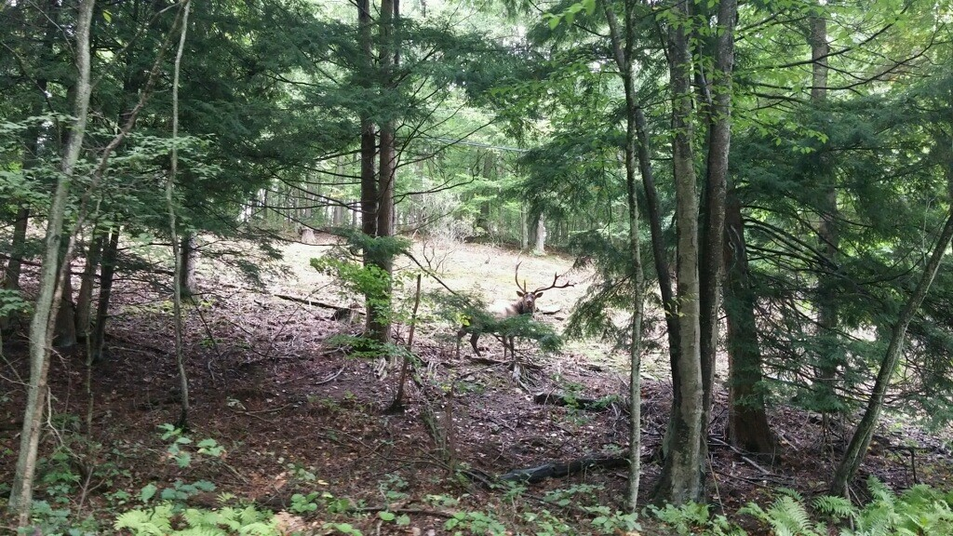

**Quehanna Elk Quest 2018**

This weekend 22 members headed north to Elk County to see Pennsylvania's beautiful elk! Did you know that elk are also called wapiti? Wapiti is the Native American word for "light colored deer". The picture above was snapped by Joe early into the QEQ trip! Send us your photos at [**ktaadmin@kta-hike.org**](mailto:ktaadmin@kta-hike.org)!

Volunteer/Maintenance Corner

**A Message From the DCNR Conservation Volunteer System**

*by Richard Deppen,* [***rdeppen@pa.gov***](mailto:rdeppen@pa.gov)

The Department of Conservation and Natural Resources’ (DCNR’s) Bureau of Forestry is in the process of revising the William Penn State Forest Resource Management Plan (SFRMP). A district-level SFRMP, written for each of the bureau’s 20 state forest districts, provides a localized overview of district resources, as well as priorities for how each district’s state forest land is managed.

The William Penn SFRMP serves 2 primary functions. The first is to provide a framework for bureau staff to approach its work and make management decisions; the second, to communicate to stakeholders—that is, the citizens of Pennsylvania, who own the state forest system—how their forest is being managed.

As part of the revision process, the bureau wishes to collect public input on a draft version of the William Penn SFRMP. The staff of William Penn State Forest hosted a public meeting on September 26 at French Creek State Park to collect input. Comments can be submitted via mail, email, or an online survey. Comments will be accepted until 2 months after the public meeting date.

The bureau has posted the draft William Penn SFRMP on the district [**webpage**](https://www.dcnr.pa.gov/StateForests/FindAForest/WilliamPenn/Pages/default.aspx).

Questions or comments about the public meeting or the William Penn SFRMP can be directed to the district office at [**FD17@pa.gov**](mailto:FD17@pa.gov) or 610-582-9660.



**Palmerton Trail Project**

**2018 ATC Mid-Atlantic Trail Crew**

We’re excited to announce the start of the Palmerton Trail Project, involving the construction of the Appalachian Trail (AT) from Lehigh Furnace Gap to Little Gap, the Winter Trail, and a new side trail to the Outerbridge Shelter in permanent, sustainable alignments. In 2018, the Appalachian Trail Conservancy’s (ATC’s) Mid-Atlantic Trail Crew will kick this off by working on National Park Service land near Little Gap.

Volunteers from KTA and other nearby trail clubs are invited to come out and work with the Trail Crew—themselves 6 or so volunteers, recruited from all over to work on AT projects—led by an ATC-employed crew leader. With this type of work, more is not always better, so we will attempt to limit additional volunteers to just 2 or so per day and spread them out over more days.

To ensure that everyone is properly equipped with personal protective equipment and that we have enough tools, we request everyone wanting to attend to register in advance.

The work

In a word—strenuous!

Schedule

The Mid-Atlantic Trail Crew works a Thursday-to-Monday schedule, with travel to the project on Thursday and return to its base near Carlisle on Monday. The crew will be working out of Palmerton during the following October sessions:

10/4–10/8

10/11–10/15

10/18–10/22

10/25–10/29

While the crew normally works on Thursdays, arrival time after a drive-up from Carlisle will be somewhat unpredictable. Departure on Monday will likely be around noon.

What to wear

The work will be new trail construction in rocky terrain, not blazing or brushing an existing trail. We strongly urge anyone planning to attend to wear boots (either hiking boots or work boots, not sneakers, trail runners, or hiking shoes) and long pants. As with hiking, wearing lots of cotton may not be the best choice.

What to bring

Day pack, several liters of water/fluids, snacks and lunch, clothing layers appropriate for the expected weather, and rain gear.

What we will provide

Tools, personal protective equipment, instruction, nagging about safety…

How to sign up

Please contact Bob Sickley at ATC: 717-255-0179 (office), 717-448-8720 (cell), or bsickley@appalachiantrail.org.

**Slackpack Volunteers Wanted!**

KTA is in need of a volunteer or volunteers to help lead the Black Forest Trail Slackpack October 26-29, 2018 in the Pine Creek Gorge, Lycoming Co.

Lead the slackpackers for one or more days! KTA will be providing meals and assisting with shuttles doing the event. All you have to do is show up and lead a small group of eager hikers on a scenic and beautiful day of hiking one of Pennsylvania’s most beautiful trails.

For more information or to volunteer call 717-766-9690 or email Joe Neville [jneville@kta-hike.org](mailto:jneville@kta-hike.org).

Hikers’ Corner

**Thunder Swamp Trail Care Encounters (Surprise!) Good Weather**

*by Ed Lawrence, KTA Trail Care Coordinator*

This is the third consecutive year that KTA Trail Care volunteers have had bear sightings while working on the 45-mile network of interconnecting trails in Delaware State Forest that make up the Thunder Swamp Trail (TST) system. The TST, in the heart of the Pocono Mountains, is a designated orange-blazed state forest hiking trail.

Work this year focused on the main loop, bisected by Route 402. Over a 2½-day rain-free weekend, 153 hours of work was accomplished by the 8 people who showed up at the Resica Falls Boy Scouts base camp. Chainsaw crews cleared hundreds of blowdowns from the entire loop, including many treetops, limbs, and saplings that had been bent or broken by winter ice and snow. Two thirds of the trail were reblazed and lopped by a diligent paint crew, and 2 sections between the Southern Gateway east to Snow Hill Road and west to the bridge over Red Rock Run were brushcut.

Special thanks goes to Diane Sickler, who prepared (at home) and brought to camp a scrumptious dinner on Friday night and made breakfast for everyone on Saturday morning. Other volunteers coming to the aid of the TST were Mary Ladish, Wanda Shirk, Elwood Loudenslager, John Eveler, Tony Robbins, Tom Bastian, and Ed Lawrence.

Next year’s project will be to clear the remaining section north of Snow Hill Road to Route 402. Your help would be appreciated.

**Family Hike!**

The Hike District 10 will offer this month will be Long Fork Loop.

Oct. 7, 10 AM (arrive 5 min. early) Meet at Hyner Run State Park at the DHT Trailhead.

Bring water, lunch, camera and walking stick. The hike is 4.7 miles, moderately strenuous. Forester Lin Greenaway and Robert Merrill will be leading the hike. Dogs on leashes are welcome! Contact [**Ted Ligenza**](mailto:tligenza@pa.gov) for more info.

Community Calendar

October 6: Code Orange 1 Day - Gifford Pinchot State Park

October 7: Family Hike: Long Fork Loop, Hyner Run State Park 10 AM

October 12-14: Fall Hiking Weekend, Williamsport, PA

*October 25-28: Trail Care BTD - Joe Gmiter Trail*

October 26-29: **SOLD OUT!** Black Forest Trail Slackpack

*November 1-4: Trail Care BTD - Bucktail Path*

November 2-4: **SOLD OUT!** Gettysburg Hiking Weekend, Gettysburg, PA

**Want your club or organization featured on our calendar?**

KTA will promote your club/organization's major events through *The Keystone Hiker*, Facebook, and our website. ***It's a perk of membership!***

Just submit a list with date, time, location, and link to web page for only those events that the public should see, to [**info@kta-hike.org**](mailto:info@kta-hike.org).

**Shop the KTA Bookstore**

KTA publishes and sells maps, guidebooks, and patches related to hiking trails in Pennsylvania. Members receive at least a 10% discount! Click the link to check out our online bookstore.

<http://www.kta-hike.org/ktas-bookstore.html>

**Amazon Smile**

The next time you shop online, use Amazon Smile and choose Keystone Trails Association. It doesn’t cost you any extra: Amazon donates 0.5% of the purchase price to Keystone Trails Association.

**Newsletter Submissions**

This newsletter is published monthly by Keystone Trails Association. Submissions are accepted on a rolling basis. Opinions expressed are those of the listed authors. The Editor encourages submissions reflecting all viewpoints, but reserves the right to edit material. You are encouraged to submit material (even just a trail closing or care alert!) to Cameron Elo, at ktaadmin@kta-hike.org. The deadline for newsletter submissions is the 15th of the prior month. Submissions received after that time will be considered for the next month.