KEYSTONE TRAILS ASSOCIATION
46 E Main St
Mechanicsburg, PA 17055
717.766.9690
www.kta-hike.org
info@kta-hike.org
MAIL ORDER PRICE LIST
Shipping cost: $6.95 first item; $1.00 each additional item. PA residents please add 6% sales tax to total.

PENNSYLVANIA HIKING TRAILS, 13th Edition 2008  The thirteenth edition is dedicated to the many hundreds of volunteers who collectively contribute more than 30,000 hours each year to build and maintain the state’s wonderful hiking trails. Divided into nine regions, the hiking opportunities in this edition are vast, exciting and diverse. There are areas of great scenic beauty and secluded wilderness. This book is meant to create interest among hikers in the trails described and lead them to explore more hiking opportunities. Includes contact information, directions and some overview maps. 236 pages, 5.5” x 9”, paperback.  Item PHT 08  KTA Members $9.45  Others $10.50 |  |  | 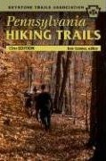

PENNSYLVANIA APPALACHIAN TRAIL

GUIDEBOOK AND MAPS

The eleventh (2009) edition of the Guidebook includes detailed trail descriptions, with tables of distances for all 229.7 miles of the Appalachian Trail located within the borders of Pennsylvania. Maps are multi-color, printed on heavy waterproof material. All maps show route of AT with elevation profiles, side trails, and other general information.
Item  ATG09  MC1-6  MC7-8  MC9-11  MC12-13  MC14  ATM98 | Members/Others  $8.40/$11.55  $12.80/$14.20  $6.40/$7.15  $6.10/$6.75  $6.10/$6.75  $6.10/$6.75  $39.90/$46.20 | Description  Appalachian Trail Guide - Pennsylvania  Sec. 1-6: Delaware Water Gap to Swatara Gap  Sec. 7-8: Swatara Gap to Susquehanna River  Sec. 9-11: Susquehanna River to PA Route 94  Sec. 12-13: PA Route 94 to US Route 30  Sec. 14: US Route 30 to the Maryland line  Complete set with guidebook and all five maps described above
GUIDE TO HIKING TRAILS IN PENNSYLVANIA MAP

The Keystone Trails Association has produced a map that highlights the state’s 29 long distance hiking trails with short trail descriptions and links to appropriate websites for additional trail information. 24" x 36" (folds to 3" x 8"), color map

Item MPHT
KTA Members $1.00
Others $2.00

PENNSYLVANIA HIKING TRAILS BOOK & MAP SET  Pennsylvania Hiking Trails, 13th Edition and the new Guide to Hiking Trails in Pennsylvania map are now available in a convenient set! Novice and experienced hikers alike will benefit from the detailed trail descriptions of hiking trails across the state. Learn more about Pennsylvania's wonderful network of hiking trails - including 29 long-distance hiking trails - while exploring hiking opportunities close to your home and in different parts of the state.  Pennsylvania Hiking Trails, 13th Edition, 236 pages, 5.5” x 9”, paperback.  Guide to Hiking Trails in Pennsylvania Map, 24" x 36" (folds to 3" x 8"), color map  Item PHTSET  KTA Members $10.45  Others $11.45 |  |  | 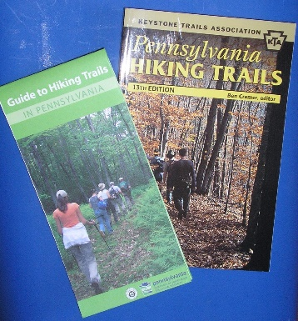
GUIDE TO THE HORSE-SHOE TRAIL

The Horse-Shoe Trail Club’s 23rd edition of their guide to the Horse-Shoe Trail “from Valley Forge to Stony Mountain.” Paperback, 2006.

Item HST
KTA Members $13.65
Others $15.00
GUIDE TO THE MID STATE TRAIL IN PENNSYLVANIA

Included in this map and guide set is the completely revised 12th (2012) edition of Guide to the Mid State Trail in Pennsylvania, along with new color maps of the trail.

Item MST12
KTA Members $35.90
Others $39.90
MID STATE TRAIL MAP 301-306: I-68 TO US 22  Including other trails in and around Buchanan State Forest, SGL 73, 97, & 118, and Lower Trail  Bedford, Blair, & Huntingdon (Part) Counties  Item MST301  KTA Members $12.95  Others $13.95 |  |  | 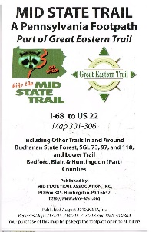
MID STATE TRAIL MAP 307-311: US 22 TO PA 192  Including other trails in and around Rothrock & Bald Eagle State Forests & bordering parks & recreation areas  Centre, Huntingdon, Mifflin, & Union (part) Counties  Item MST307  KTA Members $12.95  Others $13.95 |  |  | 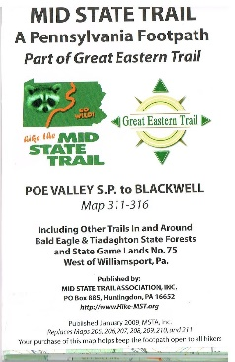
MID STATE TRAIL MAP 311-316: Poe Valley S.P. to Blackwell  Including other trails in and around Bald Eagle & Tiadaghton State Forests and SGL 75  West of Williamsport, PA  Item MST311  KTA Members $12.95  Others $13.95 |  |  | 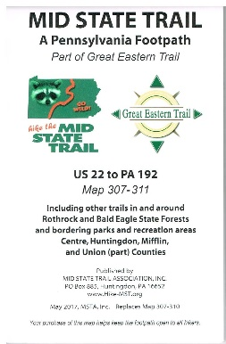
MID STATE TRAIL MAP PACKAGE  All three maps: 301-316.  Item MST301-316  KTA Members $36.95  Others $39.95 |  |  | 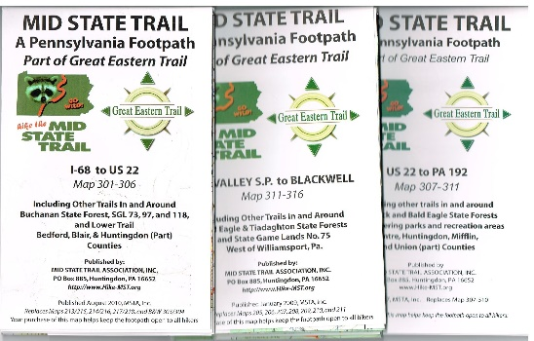
HIKER’S GUIDE TO THE BUCKTAIL PATH  Field work and text by Jim and Ginny Owen. Map and general editing by Jean Aron (1998.)  Item BTPG98  KTA Members $5.20  Others $5.80 |  |  | 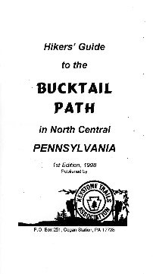
LOYALSOCK TRAIL GUIDE  The Alpine Club of Williamsport’s 19th revision of their venerable guide to the Loyalsock Trail. Includes 3 color maps. Paperback, 2015.  Item LTG  KTA Members $14.00  Others $15.00 |  |  | 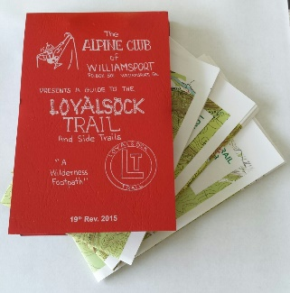
JOHN P. SAYLOR TRAIL GUIDEBOOK

The third in the PAHikes Trail Guide Series. This pocket-size trail guide contains 58 pages describing the John P. Saylor Trail. Inside you’ll find turn-by-turn directions for hiking this double-loop trail located on the Allegheny Plateau. Included with the guidebook is a full color map. This map shows the route of the trail and indicates distances, parking areas, and points of interest. 4.25” x 5.5”. Map, 2-sided, full color, 8.5” x 11”.

Item PAH504
KTA Members $8.00
Others $8.95

MASON-DIXON TRAIL MAPS  Complete set of ten (10) maps to the 193 miles of trail that make up the Mason-Dixon Trail System (2012).  Item MDT  KTA Members $14.20  Others $15.75 |  |  | 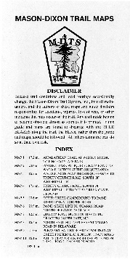
TUSCARORA TRAIL GUIDEBOOKS AND MAPS  The Tuscarora Trail Guidebooks and Maps are all published by the Potomac Appalachian Trail Club (PATC).  The Tuscarora Trail, A Guide to the North Half in Maryland & Pennsylvania. Fifth Edition (2016); 88 pages; 4.25” x7”.  Item TTG97  KTA Members $10.80  Others $12.00  The Tuscarora Trail, A Guide to the South Half in West Virginia and Virginia. (2013); 96 pages.  Item TTG297  KTA Members $10.80  Others $12.00  Tuscarora Trail Map J (Appalachian Trail Junction in PA to PA Route 641) (2012). Multi-colored, on heavyweight waterproof stock; 17” x 32”, folded to 4” x 8.5”; elevation profile.  Item MTTJ  KTA Members $6.40  Others $9.45  Tuscarora Trail Map K (PA Route 641 to Hancock, MD) (2009). Same features as Map J.  Item TTMK  KTA Members $6.40  Others $9.45 |  |  | 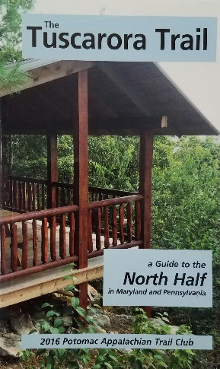  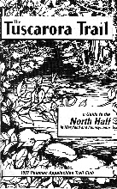
Guide to the Allegheny Front Trail -

The Allegheny Front Trail (AFT) is a 41.75 mile-long loop trail in Moshannon State Forest in western Centre County, Pennsylvania that roughly circles Black Moshannon State Park. Except for the short distance within the state park boundaries, the entire length of the AFT is within the state forest. This book by Ben Cramer provides detailed guidance on hiking the AFT. Turn-by-turn instructions, photos, and maps provide you with the information you need to enjoy the trail and the scenery of the Moshannon State Forest and the Allegheny Front. 2nd Edition; by Ben Cramer; 110 pages; Dimensions: 6.5" x 4.5"

Item AFT
KTA Members $13.00
Others $15.75

A Grip on the mane of life

After serving four and a half years in the army during WWII-mostly in the battle-torn islands of the South Pacific-and along the way losing his best friend at Iwo Jima, Earl Shaffer came home to Pennsylvania with a large dose of military depression. After rattling around for a while he decided to act upon a prewar dream of hiking the entire Appalachian Trail, a decision that was spurred by reading a magazine article stating that such a feat was likely impossible. Earl achieved his goal, and history's muse presented him with a personal niche in her gallery. Over the course of three decades he wrote a memoir of that hike which was published by the Appalachian Trail Conference as Walking with Spring. The book became an instant hiking classic. Most of Earl's writing was devoted to his first love, poetry. Earl penned more than a thousand poems during his lifetime, a trove that includes a respectable number of polished gems. In mid-career he returned to hiking. In 1963 he hiked five hundred miles of the Cascade Crest Trail, and in 1965 he again hiked the entire Appalachian Trail-this time in the opposite direction. When not hiking, Earl spent most of his free time working on the Trail. He built trail, constructed shelters, and masterminded a major trail relocation in Pennsylvania. These were not his only interests. Earl was moved by the plight of Native Americans. In the early 1960s Earl played an active role in the ultimately failed effort to stop construction of Pennsylvania's Kinzua Dam. After what one would think was already a full and productive life, Earl had yet another dream-his grand finale. In 1998, Earl decided to celebrate the fiftieth anniversary of his first A.T. thru-hike by doing an encore. Just a few weeks shy of his eightieth birthday Earl Shaffer climbed yet again to the crest of Maine's mile-high mountain, Katahdin, whereupon the Appalachian Trail icon became a national legend. This book is his story.

Item Grip on Mane
KTA Members $12.00
Others $12.00

old loggers path guide

The Old Loggers Path (OLP) is a great walking path for beginner and experienced hikers alike. This looped trail explores the Loyalsock State Forest for 27.8 miles. In this guide you'll find turn-by-turn directions for hiking the OLP along with pictures and a brief description about the geology of the area. Included with the guidebook is a full color map. This map shows the route of the trail and indicates distances, elevation profile, parking areas, and vistas. 58 pages; Dimensions: 5.5" x 4.25". Includes 8.5" x 11" full color waterproof topographical map; by Dave Gantz.

Item OLP
KTA Members $8.00
Others $9.75

foot trails of the moshannon and elk state forests  This book contains descriptive trail guidance for the Quehanna Trail and the Allegheny Front Trail. It also describes the many other trails found in the Quehanna Wild Area, as well as the trails located in the Moshannon and southern Elk State Forests. In addition to details regarding the physical aspects of the trails, you'll also find plenty of extra information contained here. Historical insight and fellow hikers' stories add to the enjoyment and discovery of the trails in the Quehanna and Black Moshannon areas. By Ralph Seeley.  Item MOSH  KTA Member $13.45  Others $14.95 |  |  | 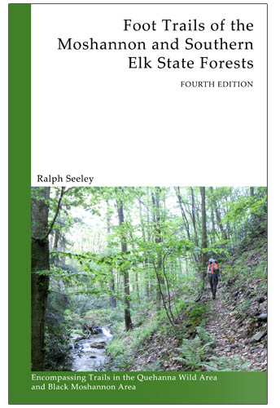
NEW! Guide to the Quehanna Trail

The Guide to the Quehanna Trail is another in the PA Hikes series. This pocket-sized guide contains 151 pages describing the Quehanna Trail. Inside you’ll find turn-by-turn directions for this oval-shaped loop trail in the Moshannan and Elk State Forests. Included with the guidebook are 4 color maps (2 2-sided pages) showing the route of the trail, vistas, parking, and optional side trails. Elevation profile also included. (2016); by Ben Cramer; 4.5” x 6.5”

Item QTG
KTA Members $17.95
Others $19.95
NEW! The chuck keiper trail guide  The Chuck Keiper Trail Guide is another in the PA Hikes series. This pocket-sized guide contains 60 pages describing the Chuck Keiper Trail. Inside you’ll find turn-by-turn directions for this loop on the Allegheny Plateau, information about the area, geology, parking, and more. Included is a 2-sided color map printed on water-resistant paper. (2016); by Dave Gantz; 4.5” x 6.5”  Item CKTG  KTA Members $11.65  Others $12.95 |  |  | 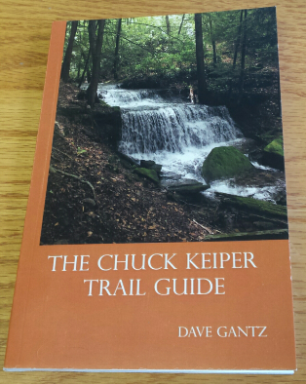
GUIDE TO THE ELK TRAIL  The Guide to the Elk Trail is another in the PA Hikes series. This pocket-sized guide contains 55 pages describing the Elk Trail and the nearby Fred Woods Trail. Inside you’ll find turn-by-turn directions for this 15.6 mile segment trail near Benezette and information on local resources. Included is a 2-sided color map printed on water-resistant paper. (2016); by Ben Cramer; 5.5” x 4.5”  Item ETG  KTA Members $7.15  Others $7.95 |  |  | 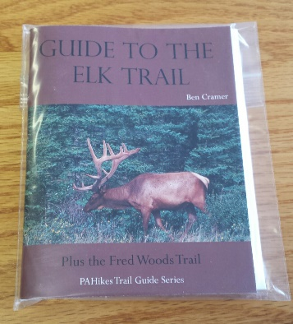
A Guide to the Edible and Medicinal Plants of the Finger Lakes Trail.

From Pisgah Press: Heather Houskeeper’s A Guide to the Edible and Medicinal Plants of the Finger Lakes Trail is a practical guide to identifying and utilizing the plants found along the almost 1,000-mile-long hiking trail. Many of the plants are found throughout New York State’s rolling hills, deep river valleys, rugged mountain tops, grassy meadows, and even the edges of freshly sown farm fields. No matter where the hiker may be on or off the trail, food and medicine abound. Spiral bound, 143 pages with color photos. Heather A. Houskeeper
Item FLT
KTA Members: $21.60
Others: $24.00
NEW! KTA Embroidered Hat
The latest in KTA fashion

100% cotton, khaki hat with embroidered KTA Logo
Item HAT
KTA Members $18.00
Others $22.00

PATCHES  KTA LOGO. Round; 3”; cloth; green and brown on white  Item P1  KTA Members $4.00  Others $5.00  OLD LOGGER’S PATH. Round; 4”; cloth; five colors  Item P3  KTA Members $4.00  Others $5.00  CHUCK KEIPER TRAIL. Round; 3”; cloth; six colors  Item CKPatch  KTA Members $4.00  Others $5.00  DONUT HOLE TRAIL. Round; 3”; cloth; four colors  Item DHTPatch  KTA Members $4.00  Others $5.00  Quehanna Trail. Round; 3”; cloth; six colors  Item QTP  KTA Members $4.00  Others $5.00  LAUREL HIGHLANDS TRAIL. Diamond; 5” x 3”; cloth; 6 colors  Item LHTPatch  KTA Members $4.00  Others $5.00  BLACK FOREST TRAIL. Round; 3”; cloth; 7 colors  Item BFTPatch  KTA Members $4.00  Others $5.00  ALLEGHENY FRONT TRAIL. Round; 3”; cloth; 7 colors  Item AFTPatch  KTA Members $4.00  Others $5.00 |  |  | 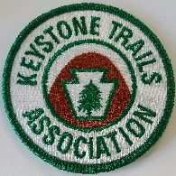  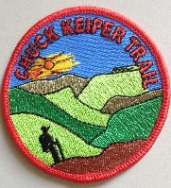  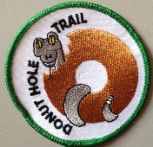  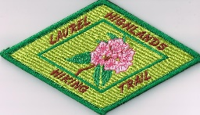  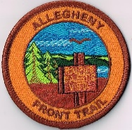
Hiking the Susquehannock Trail – by Ben Cramer
The Susquehannock Trail System (STS) is an 83 mile-long loop trail, plus several connecting trails, in North-Central Pennsylvania. The main STS is mostly in Potter County, one of the least inhabited areas of Pennsylvania, so the Susquehannock Trail System offers a special sense of remote solitude.
Ben Cramer provides turn-by-turn directions in both miles and kilometers, as well as areas of poor or good water quality, and potential camping spots along the trail. Also included are elevation profiles and details on some of the side trails found here, including the West Branch Trail, East Fork Trail, North Link and South Link Trails. Guide is paperback, 264 pages, 6.0 x 4.0 x 0.6 inches. Maps measure 8.5" x 11", full color both sides, and printed on water proof paper.

Item SUSQTrail
KTA Members $18.00
Others $20.00
Purple Lizard Maps
Rugged, waterproof and tear-resistant maps.

Bald Eagle Lizard Map: Includes MST and Reeds Gap Spur
Item BALDELiz
KTA Members $13.95
Others $14.95

Raystown Lizard Map: Includes MST, SST, and Terrace Mountain Trail
Item RAYSTOWNLiz
KTA Members $13.95
Others $14.95

Rothrock Lizard Map: 300 miles of trails including SST and MST
Item ROTHROCKLiz
KTA Members $13.95
Others $14.95

Pine Creek Lizard Map: Includes MST, BFT, WRT, Golden Eagle Trail, and portions of the Donut Hole Trail, T Squared Trail, and Susquehannock Trail (north and south link trails)
Item PINECRLiz
KTA Member $13.95
Others $14.95

Moshannon-Quehanna Lizard Map: Includes QT, Freds Woods Trail, southern portion of Bucktail Path, and AFT
Item MOSHQUELiz
KTA Member $13.95
Others $14.95

Michaux Lizard Map: Includes 40 miles of the AT including the midpoint and ATC museum.
Item MICHAUXLiz
KTA Member $13.95
Others $14.95

